**Final Project Report**

**CPSC473**

**Fall 2018**

**Project**: ABC Restaurant

**Team members**: Su Htet ([suhtet@csu.fullerton.edu](mailto:suhtet@csu.fullerton.edu))

Mike Souchito ([asdefmike@csu.fullerton.edu](mailto:asdefmike@csu.fullerton.edu))

**GitHub link:** <https://github.com/SuHtet/CPSC473_finalProject>

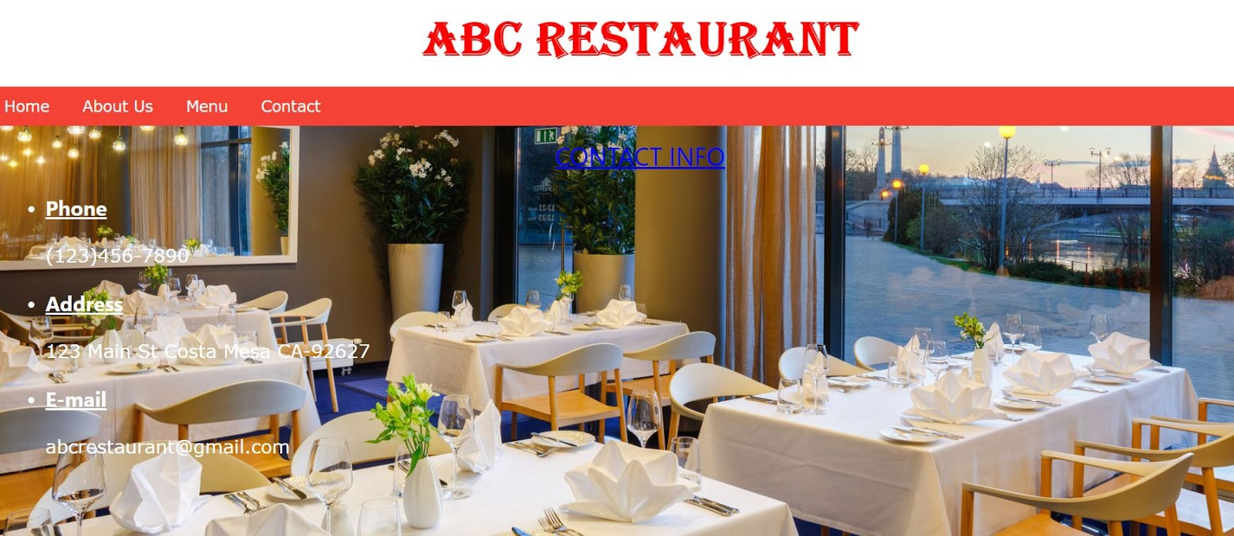

The goal of this project is to create restaurant website that can function as a

restaurant. The user interface of this website is once the user opens the website, they

can see the main page of the website. We build our restaurant website with different

tabs such as Home, About Us, Menu, and Contact. From those different tabs, users can

navigate to each tab by clicking on the tab at the top of the page.

When the user clicks on **Home** tab, they will see pictures of the most popular

dishes from our restaurant with the description for each dish.

For the **About Us** page, the user will know about the history of our restaurant,

the motto and the categories of menu that we serve in our restaurant.

On the **Menu** page, the user will find different categories of menu that we serve

in our restaurant which are Breakfast Specialities, Salads and Lunch Specialities. There

is a textbox named ‘Total’ at the bottom of the menu page where user can see how

much the total price of the food they choose. Under each category, we have different

dishes with the name and the price of the dish. There is also ‘Quantity’ with ‘+’ and ‘-’

buttons. The user can add the food by clicking the ‘+’ button and the amount of the price

will be added to the ‘Total’ textbox. When the user wants to subtract the amount of the

food, they can just click the ‘-’ button and the amount will be reduced in the ‘Total’

textbox. User can add multiple dishes just by clicking ‘+’ button under each dish and the

amount will be added to the ‘Total’ textbox.

At the very bottom of the **Menu** page, there is a link named ‘Tips Calculator and

Bill Splitter’. When the user clicks on that link, it will navigate to a calculator where they

can calculate the tips and they can also use it to split the bill among the number of

people they want. The user can just type in the amount of bill, and the default

percentage for the tip is 15% but the user can change the percentage by simply type in

the amount in percent. Then they can type in the amount of person they want to split the

bill and click ‘Calculate’. The calculator will calculate the total amount of money

including tips, total including tips for each person, total tips amount and tips for each

person. By clicking ‘Clear’ button, it will clear all the fields except the default percentage

for tip.

On the **Contact** page, the user will find the restaurant’s information including

phone number, address and email address.

We use mainly HTML to implement this website. We also use Javscript to write

functions to navigate to the different pages and also to calculate the total amount of

money for food item that the user selects. Then we use CSS stylesheet for the tabs and

the background image.